**Bit Plane Slicing**   
In Bit-plane slicing, we divide the image into bit planes. This is done by first converting the pixel values in the binary form and then dividing it into bit planes

|  |  |  |  |  |  |  |  |  |  |  |
| --- | --- | --- | --- | --- | --- | --- | --- | --- | --- | --- |
| In [7]:  In [8]:  Out[8]:  In [9]: | |  | | --- | | **import** numpy **as** np  **from** PIL **import** Image  **import** matplotlib.pyplot **as** plt |  |  | | --- | | *# reading image and converting to gray scale*  img **=** Image**.**open('../images/tiger.jpg')**.**convert('L') *# display image*  img |      |  |  |  |  |  |  |  | | --- | --- | --- | --- | --- | --- | --- | | **def** bit_slicing_function(input_image):  img **=** input_image**.**resize((400,400), Image**.**Resampling**.**LANCZOS) *# convert to numpy array*   |  | | --- | | numpy_image **=** np**.**array(img) |  |  | | --- | | fig **=** plt**.**figure() |   fig**.**set_figheight(20)   |  | | --- | | fig**.**set_figwidth(20) |  |  | | --- | | fig**.**add_subplot(3,3,1) |   plt**.**imshow(img, cmap**=**'gray')   |  | | --- | | plt**.**title('original image') |  |  | | --- | | *#Iterate over each pixel and change pixel value to binary using* |   *np.binary_repr() and store it in a list.*  lst **=**[]   **for** i **in** range(numpy_image**.**shape[0]): | |

**for** j **in** range(numpy_image**.**shape[1]):  
 lst**.**append(np**.**binary_repr(numpy_image[i][j],width**=**8))*# width = no. of bits*

*# We have a list of strings where each string represents binary pixel value. To extract bit planes we need to iterate over the strings and store the characters corresponding to bit planes into lists.*

*# Multiply with 2^(n-1) and reshape to reconstruct the bit image.* eight_bit_img **=**(np**.**array([int(i[0])**for** i **in** lst],dtype **=** np**.**uint8)**\*** 128)**.**reshape(400,400)  
 eight_bit_image **=** Image**.**fromarray(eight_bit_img)

fig**.**add_subplot(3,3,2)  
 plt**.**imshow(eight_bit_image, cmap**=**'gray')  
 plt**.**title('8 bit')

seven_bit_img **=**(np**.**array([int(i[1])**for** i **in** lst],dtype **=** np**.**uint8)**\*** 64)**.**reshape(400,400)  
 seven_bit_image **=** Image**.**fromarray(seven_bit_img)

fig**.**add_subplot(3,3,3)  
 plt**.**imshow(seven_bit_image, cmap**=**'gray')  
 plt**.**title('7 bit')

six_bit_img **=**(np**.**array([int(i[2])**for** i **in** lst],dtype **=** np**.**uint8)**\*** 32)**.**reshape(400,400)  
 six_bit_img **=** Image**.**fromarray(six_bit_img)

fig**.**add_subplot(3,3,4)  
 plt**.**imshow(six_bit_img, cmap**=**'gray')  
 plt**.**title('6 bit')

five_bit_img **=**(np**.**array([int(i[3])**for** i **in** lst],dtype **=** np**.**uint8)**\*** 16)**.**reshape(400,400)  
 five_bit_img **=** Image**.**fromarray(five_bit_img)

fig**.**add_subplot(3,3,5)  
 plt**.**imshow(five_bit_img, cmap**=**'gray')  
 plt**.**title('5 bit')

four_bit_img **=**(np**.**array([int(i[4])**for** i **in** lst],dtype **=** np**.**uint8)**\*** 8)**.**reshape(400,400)  
 four_bit_img **=** Image**.**fromarray(four_bit_img)

fig**.**add_subplot(3,3,6)  
 plt**.**imshow(four_bit_img, cmap**=**'gray')  
 plt**.**title('4 bit')

three_bit_img **=**(np**.**array([int(i[5])**for** i **in** lst],dtype **=** np**.**uint8)**\*** 4)**.**reshape(400,400)  
 three_bit_img **=** Image**.**fromarray(three_bit_img)

fig**.**add_subplot(3,3,7)  
 plt**.**imshow(three_bit_img, cmap**=**'gray')  
 plt**.**title('3 bit')

two_bit_img **=**(np**.**array([int(i[6])**for** i **in** lst],dtype **=** np**.**uint8)**\***

|  |  |  |  |  |  |  |  |
| --- | --- | --- | --- | --- | --- | --- | --- |
| 2)**.**reshape(400,400)   |  | | --- | | two_bit_img **=** Image**.**fromarray(two_bit_img) |  |  | | --- | | fig**.**add_subplot(3,3,8) |   plt**.**imshow(two_bit_img, cmap**=**'gray')   |  | | --- | | plt**.**title('2 bit') |  |  | | --- | | one_bit_img **=**(np**.**array([int(i[7])**for** i **in** lst],dtype **=** np**.**uint8)**\*** |   1)**.**reshape(400,400)   |  | | --- | | one_bit_img **=** Image**.**fromarray(one_bit_img) |  |  | | --- | | fig**.**add_subplot(3,3,9) |   plt**.**imshow(one_bit_img, cmap**=**'gray')   |  | | --- | | plt**.**title('1 bit') | |

|  |  |  |
| --- | --- | --- |
| In [10]: | |  | | --- | | bit_slicing_function(img) | |

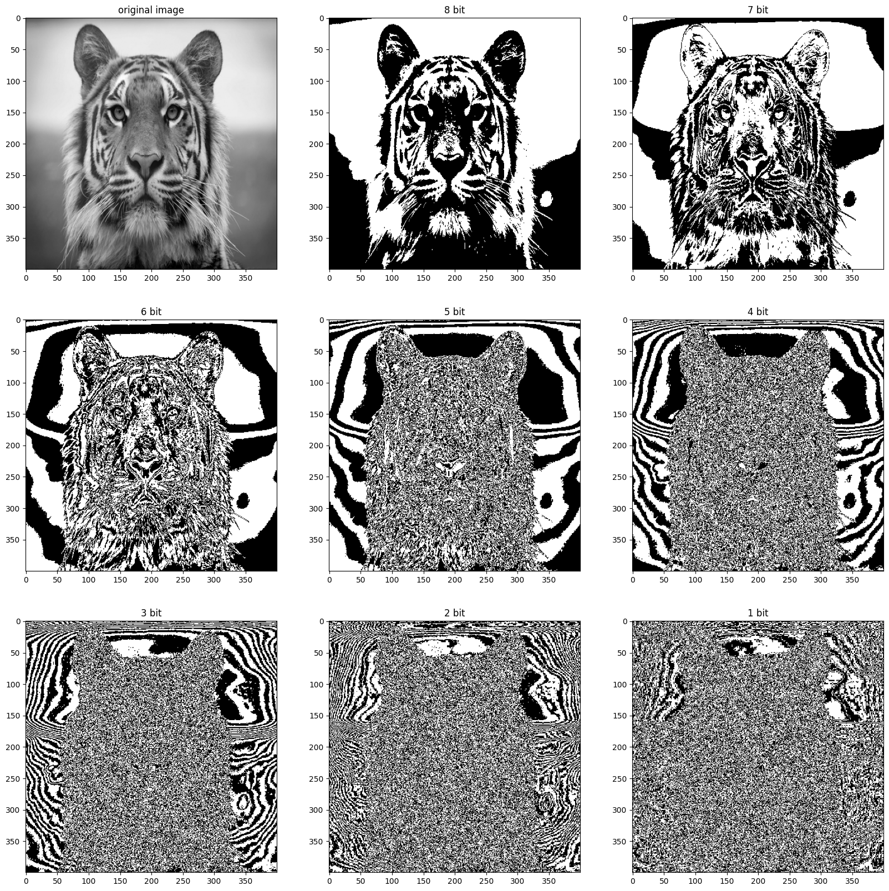

**Gray Level Slicing**

It is used to highlight a specific rangeof intensities in an image that might be of interest. Two common approaches:

 Set all the pixel values with a range of interest to one value (white) and all others to another value (black) produces a binary image.

 Brighten(or darken) pixel values in a range of interest and leave all others unchanged.

It is useful highlighting features in an image.

|  |  |  |  |  |
| --- | --- | --- | --- | --- |
| In [ ]:  In [ ]:  Out[ ]:  In [ ]: | |  | | --- | | *#import libraries*  **import** numpy **as** np  **from** PIL **import** Image  **import** matplotlib.pyplot **as** plt |  |  | | --- | | *#read the image*  *# reading image and converting to gray scale*  img **=** Image**.**open('../images/tiger.jpg')**.**convert('L') *# display image*  img |      |  | | --- | | img **=** img**.**resize((200,200), Image**.**Resampling**.**LANCZOS) *# convert to numpy array*  numpy_image **=** np**.**array(img) | |
| In [ ]: | |  |  |  | | --- | --- | --- | | |  | | --- | | numpy_image**.**shape |  |  | | --- | | row **=** numpy_image**.**shape[0] | | |

|  |  |
| --- | --- |
| |  | | --- | | column **=** numpy_image**.**shape[1] | |

Set all the pixel values with a range of interest to one value (white) and all others to

another value (black) produces a binary image.

|  |  |  |  |  |
| --- | --- | --- | --- | --- |
| In [ ]:  In [ ]:  In [ ]:  Out[ ]: | |  | | --- | | new_array **=** np**.**zeros(shape**=**(row,column)) |  |  | | --- | | **for** i **in** range(row):   **for** j **in** range(column):  new_array[i][j]**=** numpy_image[i][j] |  |  | | --- | | new_array |   array([[ 86., 86., 88., ..., 138., 138., 136.], |

[ 93., 93., 94., ..., 148., 147., 146.],  
 [ 98., 99., 100., ..., 158., 156., 155.],  
 ...,  
 [ 49., 49., 50., ..., 72., 71., 71.],  
 [ 49., 49., 49., ..., 73., 73., 72.],  
 [ 48., 49., 49., ..., 72., 72., 72.]], shape=(200, 200))

|  |  |  |
| --- | --- | --- |
| In [ ]: Out[ ]: | |  | | --- | | numpy_image |   array([[ 86, 86, 88, ..., 138, 138, 136], |

[ 93, 93, 94, ..., 148, 147, 146],  
 [ 98, 99, 100, ..., 158, 156, 155],  
 ...,  
 [ 49, 49, 50, ..., 72, 71, 71],  
 [ 49, 49, 49, ..., 73, 73, 72],  
 [ 48, 49, 49, ..., 72, 72, 72]], shape=(200, 200), dtype=uint8)

|  |  |  |  |
| --- | --- | --- | --- |
| In [ ]:  In [ ]:  Out[ ]: | |  | | --- | | **for** i **in** range(row):   **for** j **in** range(column):   **if**((numpy_image[i][j]**>**100)**&**(numpy_image[i][j]**<**150)): new_array[i][j]**=**255   **else**:  new_array[i][j]**=**0 |  |  | | --- | | new_array |   array([[ 0., 0., 0., ..., 255., 255., 255.], |

[ 0., 0., 0., ..., 255., 255., 255.],  
 [ 0., 0., 0., ..., 0., 0., 0.],  
 ...,  
 [ 0., 0., 0., ..., 0., 0., 0.],  
 [ 0., 0., 0., ..., 0., 0., 0.],  
 [ 0., 0., 0., ..., 0., 0., 0.]], shape=(200, 200))

|  |  |  |
| --- | --- | --- |
| In [ ]: | |  | | --- | | gray_level_slicing_image **=** Image**.**fromarray(new_array)  gray_level_slicing_image **=** gray_level_slicing_image**.**convert("L") gray_level_slicing_image | |

|  |  |
| --- | --- |
| Out[ ]: |  |

Brighten(or darken) pixel values in a range of interest and leave all others unchanged.

|  |  |  |  |  |
| --- | --- | --- | --- | --- |
| In [ ]:  In [ ]:  In [ ]:  Out[ ]: | |  | | --- | | new_array2 **=** np**.**zeros(shape**=**(row,column)) |  |  | | --- | | **for** i **in** range(row):   **for** j **in** range(column):   **if**((numpy_image[i][j]**>**100)**&**(numpy_image[i][j]**<**150)): new_array2[i][j]**=**0   **else**:  new_array2[i][j]**=** numpy_image[i][j] |  |  | | --- | | gray_level_slicing_image2 **=** Image**.**fromarray(new_array2)  gray_level_slicing_image2 **=** gray_level_slicing_image2**.**convert("L") gray_level_slicing_image2 | |

\***Log Transform**\*

|  |  |  |  |  |
| --- | --- | --- | --- | --- |
| In [1]:  In [2]:  In [3]: | |  | | --- | | **import** numpy **as** np  **from** PIL **import** Image  **import** matplotlib.pyplot **as** plt |  |  | | --- | | **def** log_transform(input_image):   *# resizing image*  img **=** input_image**.**resize((400,400), Image**.**Resampling**.**LANCZOS) *# convert to numpy array*   numpy_image **=** np**.**array(img)  numpy_image **=** numpy_image**/**255  numpy_image **=** numpy_image **+**1  numpy_image **=** np**.**log(numpy_image)  print(type(numpy_image))  numpy_image **=** numpy_image **\***255  numpy_image **=** np**.**around(numpy_image,decimals**=**0)  log_image **=** Image**.**fromarray(numpy_image)  log_image **=** log_image**.**convert("L")  *#plotting input and output images*   *# set up side-by-side image display*  fig **=** plt**.**figure()  fig**.**set_figheight(6)  fig**.**set_figwidth(8)  fig**.**add_subplot(1,2,1)  plt**.**imshow(img, cmap**=**'gray')  plt**.**title('original image')  fig**.**add_subplot(1,2,2)  plt**.**imshow(log_image, cmap**=**'gray')  plt**.**title('log-transform')  **return** log_image |  |  | | --- | | *# reading image and converting to gray scale*  img **=** Image**.**open("../images/tiger.jpg")**.**convert('L') *# display image*  a **=** log_transform(img) | |

<class 'numpy.ndarray'>

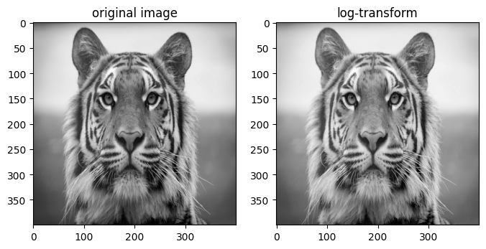

\***Logic Operators**\*

|  |  |  |  |  |  |
| --- | --- | --- | --- | --- | --- |
| In [1]:  In [2]:  Out[2]:  In [3]:  In [4]: | |  | | --- | | *#import libraries*  **import** numpy **as** np  **from** PIL **import** Image  **import** matplotlib.pyplot **as** plt |  |  | | --- | | *#read the image*  *# reading image and converting to gray scale*  img **=** Image**.**open("../images/rectangle.png")**.**convert('L') *# display image*  img |      |  | | --- | | img **=** img**.**resize((300,300), Image**.**Resampling**.**LANCZOS) *# convert to numpy array*  numpy_image **=** np**.**array(img) |  |  | | --- | | *#read the image*  *# reading image and converting to gray scale*  img2 **=** Image**.**open("../images/triangle.png")**.**convert('L') *# display image*  img2 | |

|  |  |  |  |  |
| --- | --- | --- | --- | --- |
| Out[4]:  In [5]:  In [6]:  Out[6]:  In [7]: | |  | | --- | | img2 **=** img2**.**resize((300,300), Image**.**Resampling**.**LANCZOS) *# convert to numpy array*  numpy_image2 **=** np**.**array(img2) |  |  | | --- | | *# Logic AND*  aa **=** numpy_image**\***numpy_image2  aa **=** Image**.**fromarray(aa)  aa **=** aa**.**convert("L")  aa |      |  | | --- | | *# Logic OR*  aa **=** numpy_image**+**numpy_image2  aa **=** Image**.**fromarray(aa)  aa **=** aa**.**convert("L")  aa | |

|  |  |  |
| --- | --- | --- |
| Out[7]:  In [8]:  Out[8]: | |  | | --- | | *#XOR*  aa **=** np**.**logical_xor(numpy_image, numpy_image2) aa **=** Image**.**fromarray(aa)  aa **=** aa**.**convert("L")  aa | |

\***Negative Images**\*   
Negative images are useful for enhancing white or grey detail embedded in dark regions S = max_intensity - r

|  |  |  |  |  |
| --- | --- | --- | --- | --- |
| In [4]:  In [5]:  In [6]:  Out[6]: | |  | | --- | | *#import libraries*  **import** numpy **as** np  **from** PIL **import** Image  **import** matplotlib.pyplot **as** plt |  |  | | --- | | **def** Negative_Image(image):   *# image = image.resize((400,400), Image.Resampling.LANCZOS)*  *# convert to numpy array*   numpy_image **=** np**.**array(image)  row **=** numpy_image**.**shape[0]  column **=** numpy_image**.**shape[1]  new_array **=** np**.**zeros(shape**=**(row,column))   **for** i **in** range(row):   **for** j **in** range(column):  new_array[i][j]**=**255**-** numpy_image[i][j]  negative_image **=** Image**.**fromarray(new_array)  negative_image **=** negative_image**.**convert("L")   **return** negative_image |  |  | | --- | | *# reading image and converting to gray scale*  image **=** Image**.**open('../images/tiger.jpg')**.**convert('L') *# calling negative function*  negative_image **=** Negative_Image(image)  *#displaying the images*  fig **=** plt**.**figure()  fig**.**set_figheight(8)  fig**.**set_figwidth(8)  fig**.**add_subplot(1,2,1)  plt**.**imshow(image, cmap**=**'gray')  plt**.**title('original image')  fig**.**add_subplot(1,2,2)  plt**.**imshow(negative_image, cmap**=**'gray')  plt**.**title('Negative image') |   Text(0.5, 1.0, 'Negative image') |

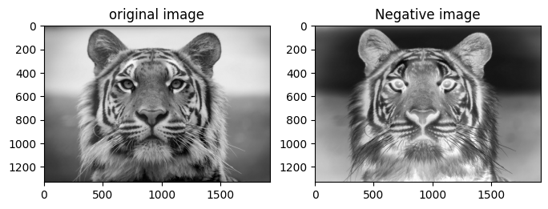

\***Power Function**\*

Power law transformations have the following form   
$S = C r ^ {\gamma}$   
S = output pixel   
r = input pixel   
C = constant   
Map a narrow range of dark input values into a wider range of output values or vice versa Varying $\gamma$ gives a whole family of curves

|  |  |  |  |
| --- | --- | --- | --- |
| In [1]:  In [2]: | |  | | --- | | **import** numpy **as** np  **from** PIL **import** Image  **import** matplotlib.pyplot **as** plt |  |  | | --- | | **def** power_function(input_image):  img **=** input_image**.**resize((400,400), Image**.**Resampling**.**LANCZOS)  *# convert to numpy array*   numpy_image **=** np**.**array(img)  numpy_image **=** numpy_image**/**255  *#transforming for different values of gamma*  *#plotting input and output images*   *# set up side-by-side image display*  fig **=** plt**.**figure()  fig**.**set_figheight(20)  fig**.**set_figwidth(20)  fig**.**add_subplot(4,4,1)  plt**.**imshow(img, cmap**=**'gray')  plt**.**title('original image')  gamma **=**0.1   **for** i **in** range(15):   *#print(i*gamma)*  numpy_image_a **=** np**.**power(numpy_image,gamma**\***(i**+**1)) numpy_image_a **=** numpy_image_a **\***255  numpy_image_a **=** np**.**around(numpy_image_a,decimals**=**0) power_image **=** Image**.**fromarray(numpy_image_a)  power_image **=** power_image**.**convert("L")  fig**.**add_subplot(4,4,i**+**2)  plt**.**imshow(power_image, cmap**=**'gray')  plt**.**title('gamma = '**+** str(round(i**\***gamma,1)))  **return** power_image | |

|  |  |  |
| --- | --- | --- |
| In [3]: | |  | | --- | | *# reading image and converting to gray scale*  img **=** Image**.**open('../images/tiger.jpg')**.**convert('L') *# Calling the power function*  a **=** power_function(img) | |

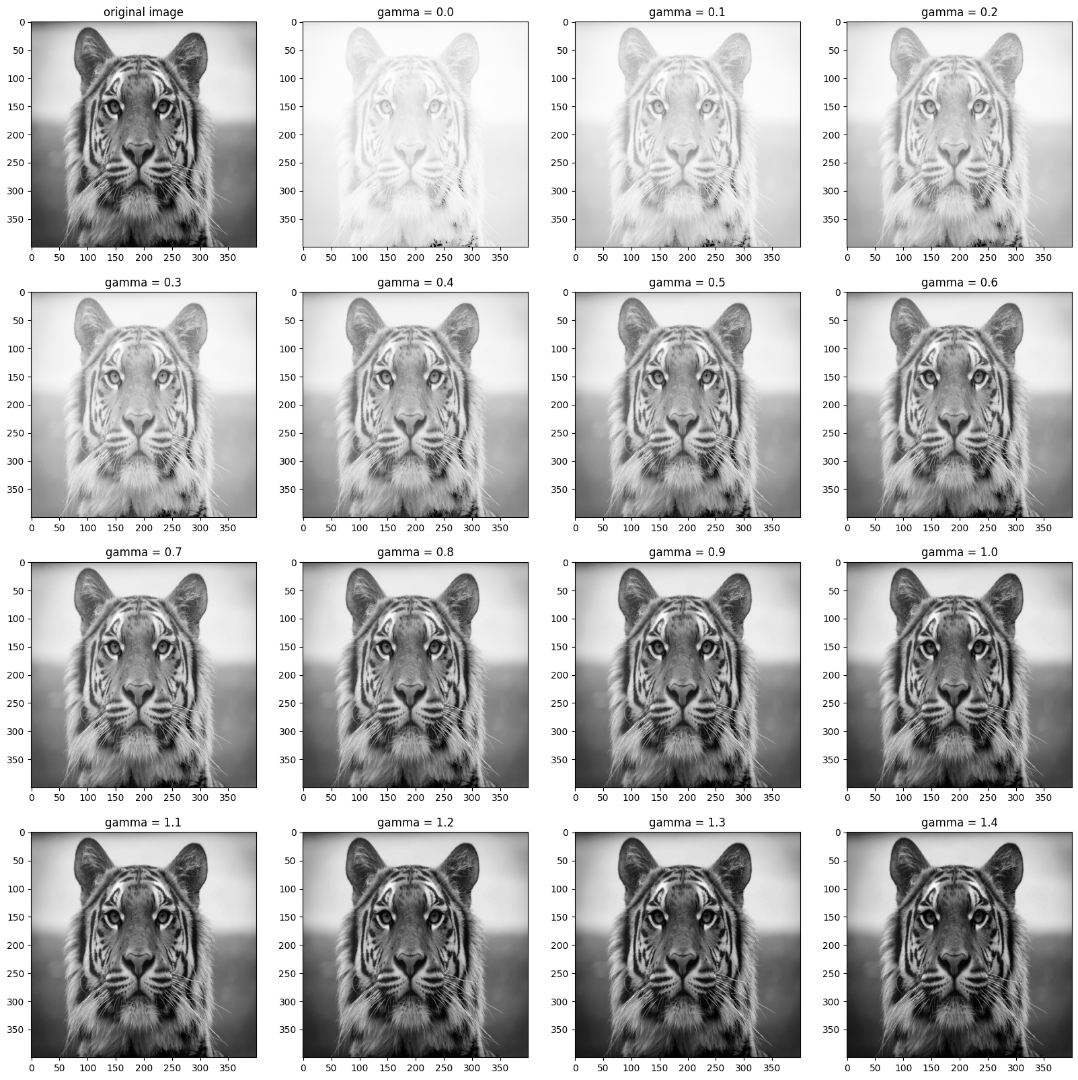

\***Thresholding**\*   
S = 1 if r>=threshold   
S = 0 if r< threshold

|  |  |  |  |  |
| --- | --- | --- | --- | --- |
| In [1]:  In [2]:  In [3]:  Out[3]: | |  | | --- | | *#import libraries*  **import** numpy **as** np  **from** PIL **import** Image  **import** matplotlib.pyplot **as** plt |  |  | | --- | | **def** Threshold_Image(image):  threshold **=** int(input("Enter Value of threshold: "))   *# image = image.resize((400,400), Image.Resampling.LANCZOS)*  *# convert to numpy array*   numpy_image **=** np**.**array(image)  row **=** numpy_image**.**shape[0]  column **=** numpy_image**.**shape[1]  new_array **=** np**.**zeros(shape**=**(row,column))  **for** i **in** range(row):  **for** j **in** range(column):   **if**(numpy_image[i][j]**>=**threshold):  new_array[i][j]**=**255   **else**:  new_array[i][j]**=**0  *#converting array back to image*  threshold_image **=** Image**.**fromarray(new_array) threshold_image **=** threshold_image**.**convert("L")  **return** threshold_image, threshold |  |  | | --- | | *# reading image and converting to gray scale*  image **=** Image**.**open('../images/tiger.jpg')**.**convert('L') *# calling negative function*  threshold_image, threshold_value **=** Threshold_Image(image)  *#displaying the images*  fig **=** plt**.**figure()  fig**.**set_figheight(20)  fig**.**set_figwidth(20)  fig**.**add_subplot(1,2,1)  plt**.**imshow(image, cmap**=**'gray')  plt**.**title('Original image')  fig**.**add_subplot(1,2,2)  plt**.**imshow(threshold_image, cmap**=**'gray')  plt**.**title(f'Threshold image (threshold: {threshold_value})') |   Text(0.5, 1.0, 'Threshold image (threshold: 130)') |

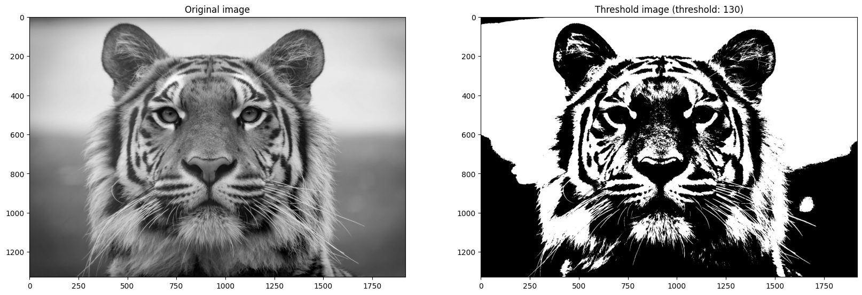

**Contrast Stretching**

|  |  |  |  |  |
| --- | --- | --- | --- | --- |
| In [1]:  In [2]:  In [3]: | |  | | --- | | **import** numpy **as** np  **from** PIL **import** Image  **import** matplotlib.pyplot **as** plt |  |  | | --- | | **def** contrast_stretching(input_image):  img **=** input_image**.**resize((500,500), Image**.**Resampling**.**LANCZOS) *#converitng it to array*  img_array **=** np**.**asarray(img)  min **=** np**.**amin(img_array)  print(min)  max **=** np**.**amax(img_array)  print(max)  range **=** max**-**min  row **=**400  column **=**400  array_b **=** np**.**zeros((row,column))  array_b **=**(((img_array **-** min)**/**range)**\***255) min **=** np**.**amin(array_b)  print(min)  max **=** np**.**amax(array_b)  print(max)  final_image **=** Image**.**fromarray(array_b) final_image**=** final_image**.**convert("L")  *# set up side-by-side image display*  fig **=** plt**.**figure()  fig**.**set_figheight(15)  fig**.**set_figwidth(15)  fig**.**add_subplot(2,2,1)  plt**.**imshow(img, cmap**=**'gray')  *#Plotting Histogram*  flat **=** img_array**.**flatten()  fig**.**add_subplot(2,2,3)  plt**.**hist(flat, bins**=**50)  fig**.**add_subplot(2,2,2)  plt**.**imshow(final_image, cmap**=**'gray')  *#Plotting Histogram*  flat2 **=** array_b**.**flatten()  fig**.**add_subplot(2,2,4)  plt**.**hist(flat2, bins**=**50)  **return** final_image |  |  | | --- | | *# reading image and converting to gray scale*  input_image **=** Image**.**open("../images/tiger.jpg")**.**convert('L') a **=** contrast_stretching(input_image) | |

0   
251   
0.0   
255.0

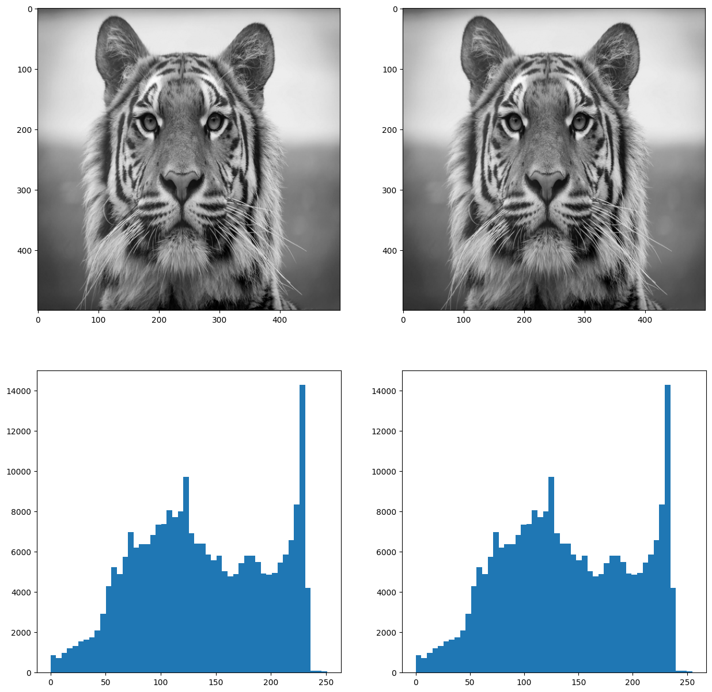

\***Histogram Equalization**\*   
The histogram of an image shows us the distribution of grey levels in the image. Histogram equalization is the process for increasing the contrast in an image by spreading the histogram out to be approximately uniformly distributed.

|  |  |  |  |
| --- | --- | --- | --- |
| In [1]:  In [2]: | |  | | --- | | **import** numpy **as** np  **from** PIL **import** Image  **import** matplotlib.pyplot **as** plt |  |  | | --- | | **def** histogram_equalization(input_image):   *# resizing image*  img **=** input_image**.**resize((300,300), Image**.**Resampling**.**LANCZOS)   *# convert our image into a numpy array*  img **=** np**.**asarray(img)   *# put pixels in a 1D array by flattening out img array*  flat **=** img**.**flatten()   *# show the histogram*   *#plt.hist(flat, bins=256)*  histogram **=** np**.**zeros(256)   *# loop through pixels and sum up counts of pixels*   **for** pixel **in** flat:  histogram[pixel]**+=**1   *#plt.plot(histogram)*  a **=** iter(histogram)  b **=**[next(a)]   **for** i **in** a:  b**.**append(b[**-**1]**+** i)  cs **=** np**.**array(b)   *# numerator & denomenator*  nj **=**(cs **-** cs**.**min())**\***255  N **=** cs**.**max()**-** cs**.**min()   *# re-normalize the cumsum*  cs **=** nj **/** N   *# cast it back to uint8 since we can't use floating point values in images* cs **=** cs**.**astype('uint8')   *# get the value from cumulative sum for every index in flat, and set that as img_new*  img_new **=** cs[flat]   *# put array back into original shape since we flattened it*  img_new **=** np**.**reshape(img_new, img**.**shape)   *# set up side-by-side image display* | |

|  |  |  |  |  |  |  |  |  |  |  |
| --- | --- | --- | --- | --- | --- | --- | --- | --- | --- | --- |
| fig **=** plt**.**figure()  fig**.**set_figheight(12)   |  | | --- | | fig**.**set_figwidth(12) |  |  | | --- | | fig**.**add_subplot(2,2,1) |  |  | | --- | | plt**.**imshow(img, cmap**=**'gray') |  |  | | --- | | *#histogram of initial image* |   fig**.**add_subplot(2,2,2)   |  | | --- | | plt**.**hist(flat, bins**=**50) |  |  | | --- | | *# display the new image* |   fig**.**add_subplot(2,2,3)   |  | | --- | | plt**.**imshow(img_new, cmap**=**'gray') |  |  | | --- | | *#histogram of final image* |   fig**.**add_subplot(2,2,4)   |  | | --- | | plt**.**hist(cs, bins**=**50) |  |  | | --- | | plt**.**show(block**=True**) | |

|  |  |  |
| --- | --- | --- |
| In [3]: | |  | | --- | | *# reading image and converting to gray scale*  img **=** Image**.**open('../images/tiger.jpg')**.**convert('L') *#Calling the histogram equalization function*  histogram_equalization(img) | |

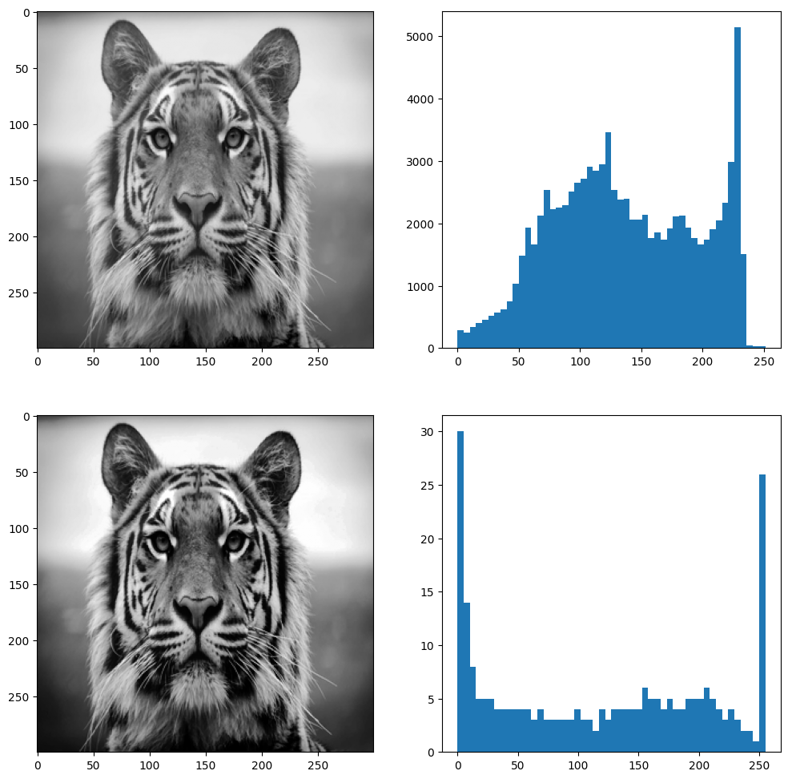

\***High Boost**\*   
High-boost = (A-1)Original - High-pass

|  |  |  |  |  |  |  |  |  |  |  |  |
| --- | --- | --- | --- | --- | --- | --- | --- | --- | --- | --- | --- |
| In [1]:  In [2]:  In [3]: | |  | | --- | | **import** numpy **as** np  **from** PIL **import** Image  **import** matplotlib.pyplot **as** plt |  |  | | --- | | **def** sharp_filter(input_image):  img **=** input_image**.**resize((400,400), Image**.**Resampling**.**LANCZOS) *# convert to numpy array*   numpy_image **=** np**.**array(img)   *# array for padding*  array_b **=** np**.**zeros((402,402))   *# to pad initial array with zeros in all side*  array_b[1:401,1:401]**=** numpy_image   *#defining filter*  filter_array **=** np**.**array([[**-**1**/**9,**-**1**/**9,**-**1**/**9],   [**-**1**/**9,8**/**9,**-**1**/**9],   [**-**1**/**9,**-**1**/**9,**-**1**/**9]])   *#creating empty list*  lst **=**[]   **for** i **in** range(400):   **for** j **in** range(400):   *#extracting part of array equal to filter size*  array_c **=** array_b[i:(3**+**i),j:(3**+**j)]   *#applying filter*  array_mul **=** np**.**multiply(filter_array,array_c)  array_sum **=** np**.**sum(array_mul)   *# putting calculated value in list*  lst**.**append(array_sum)   *# resizing lst to shape of original array*  final_array **=** np**.**resize(lst,(400,400))  final_image **=** Image**.**fromarray(final_array)  final_image**=** final_image**.**convert("L")   **return** final_image |  |  |  |  |  |  |  |  |  | | --- | --- | --- | --- | --- | --- | --- | --- | | |  | | --- | | **def** high_boost(input_image): |  |  | | --- | | high_pass **=** sharp_filter(input_image) |  |  | | --- | | img **=** input_image**.**resize((400,400), Image**.**Resampling**.**LANCZOS) |  |  | | --- | | *# convert to numpy array* |  |  | | --- | | numpy_image **=** np**.**array(img) |  |  | | --- | | A **=**3 |  |  | | --- | | high_boost **=**(A**-**1)**\***numpy_image **+** high_pass | | |

|  |  |  |  |  |  |  |  |  |
| --- | --- | --- | --- | --- | --- | --- | --- | --- |
| final_image **=** Image**.**fromarray(high_boost)   |  | | --- | | final_image**=** final_image**.**convert("L") |  |  | | --- | | fig **=** plt**.**figure() |   fig**.**set_figheight(10)   |  | | --- | | fig**.**set_figwidth(10) |  |  | | --- | | *#plotting original image* |   fig**.**add_subplot(1,2,1)  plt**.**imshow(img, cmap**=**'gray')   |  | | --- | | plt**.**title('Original') |  |  | | --- | | *#plotting filtered image* |   fig**.**add_subplot(1,2,2)  plt**.**imshow(final_image, cmap**=**'gray')   |  | | --- | | plt**.**title('High-boost image') |  |  | | --- | | **return** final_image | |

|  |  |  |
| --- | --- | --- |
| In [4]: | |  | | --- | | *# reading image and converting to gray scale*  img **=** Image**.**open('../images/tiger.jpg')**.**convert('L') *# Calling smooth function*  a **=** high_boost(img) | |

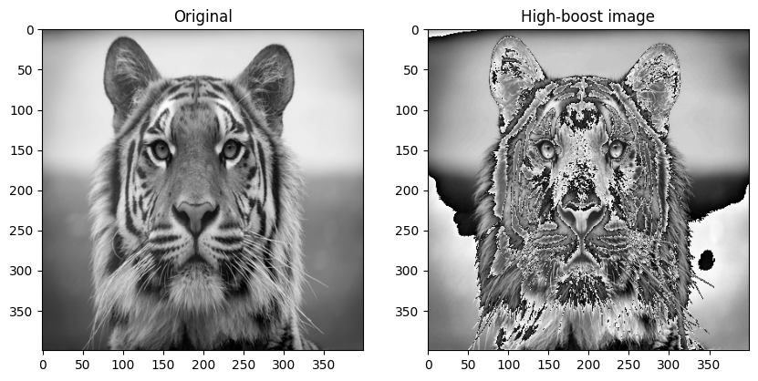

\***Median Filter**\*

|  |  |  |  |
| --- | --- | --- | --- |
| In [1]:  In [2]: | |  | | --- | | **import** numpy **as** np  **from** PIL **import** Image  **import** matplotlib.pyplot **as** plt |  |  | | --- | | **def** median_filter(input_image):  img **=** input_image**.**resize((400,400), Image**.**Resampling**.**LANCZOS)  fig **=** plt**.**figure()  fig**.**set_figheight(20)  fig**.**set_figwidth(20)  *#plotting original image*  fig**.**add_subplot(1,2,1)  plt**.**imshow(img, cmap**=**'gray')  plt**.**title('original')  *# convert to numpy array*   numpy_image **=** np**.**array(img)   *# array for padding*  array_b **=** np**.**zeros((402,402))  *# to pad initial array with zeros in all side* array_b[1:401,1:401]**=** numpy_image  *#defining filter*  *#filter_array = np.array([[1,1,1],*   *# [1,1,1],*   *# [1,1,1]])*  filter_array **=** np**.**array([[3,3,3],  [3,3,3],  [3,3,3]])  *#creating empty list*  lst **=**[]  **for** i **in** range(400):  **for** j **in** range(400):   *#extracting part of array equal to filter size* array_c **=** array_b[i:(3**+**i),j:(3**+**j)]  *#applying filter*  array_mul **=** np**.**multiply(filter_array,array_c) array_sum **=** np**.**median(array_mul)  *# putting calculated value in list*  lst**.**append(array_sum)  *# resizing lst to shape of original array* final_array **=** np**.**resize(lst,(400,400))  final_image **=** Image**.**fromarray(final_array) final_image**=** final_image**.**convert("L") | |

|  |  |  |  |  |
| --- | --- | --- | --- | --- |
| |  | | --- | | *#plotting filtered image* |  |  | | --- | | fig**.**add_subplot(1,2,2) |  |  | | --- | | plt**.**imshow(final_image, cmap**=**'gray') |  |  | | --- | | plt**.**title('filtered image') | |

|  |  |  |
| --- | --- | --- |
| In [3]: | |  | | --- | | *# reading image and converting to gray scale*  img **=** Image**.**open('../images/tiger.jpg')**.**convert('L') *# Call filter function*  median_filter(img) | |

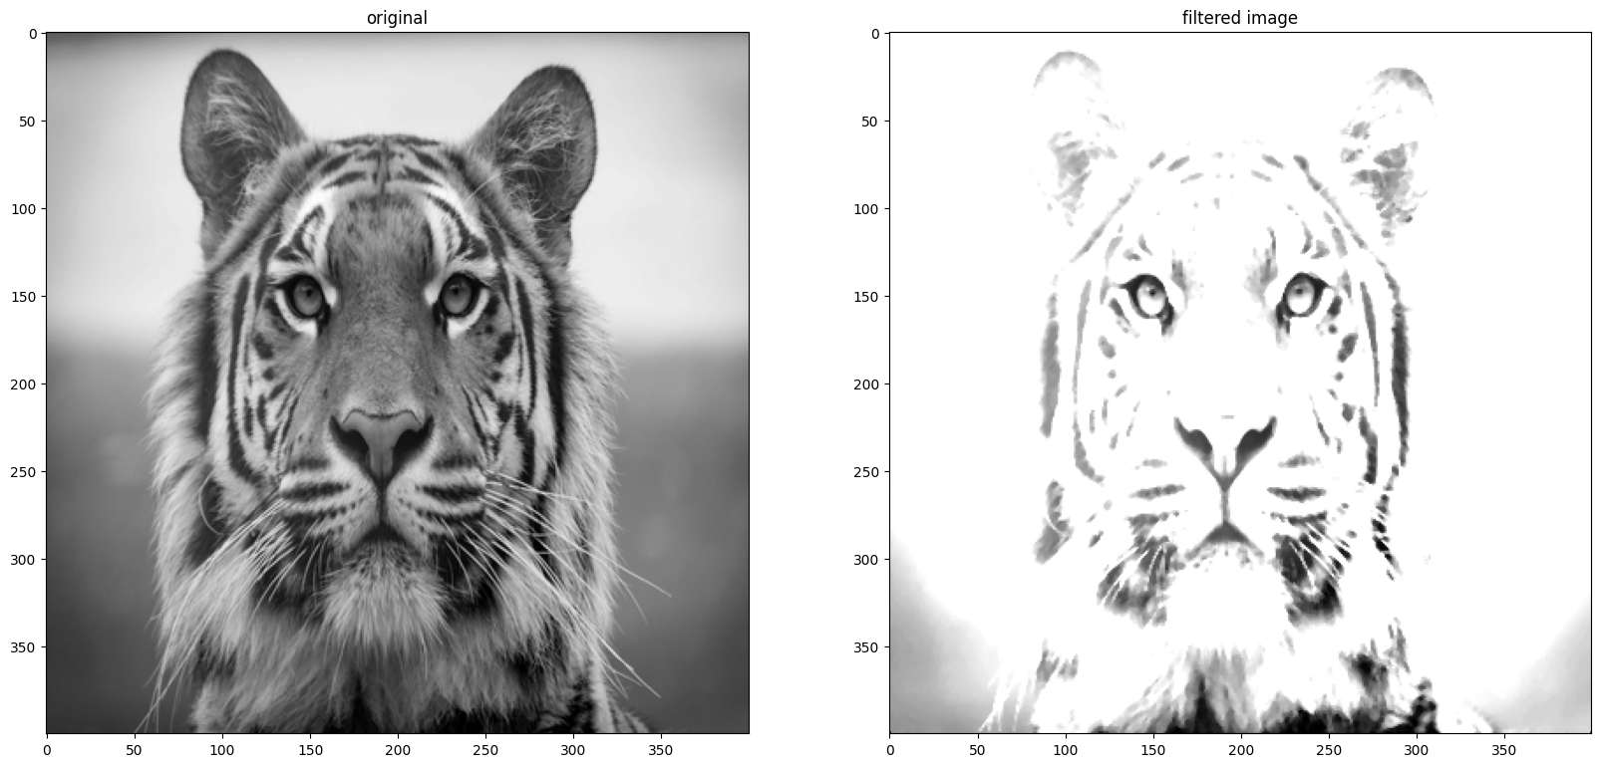

**Min Max Filter**

|  |  |  |  |
| --- | --- | --- | --- |
| In [1]:  In [2]: | |  | | --- | | **import** numpy **as** np  **from** PIL **import** Image  **import** matplotlib.pyplot **as** plt |  |  | | --- | | **def** min_filter(input_image):  img **=** input_image**.**resize((400,400), Image**.**Resampling**.**LANCZOS)  fig **=** plt**.**figure()  fig**.**set_figheight(20)  fig**.**set_figwidth(20)  *#plotting original image*  fig**.**add_subplot(1,2,1)  plt**.**imshow(img, cmap**=**'gray')  plt**.**title('original')  *# convert to numpy array*   numpy_image **=** np**.**array(img)   *# array for padding*  array_b **=** np**.**zeros((402,402))  *# to pad initial array with zeros in all side* array_b[1:401,1:401]**=** numpy_image  *#defining filter*  *#filter_array = np.array([[1,1,1],*   *# [1,1,1],*   *# [1,1,1]])*  filter_array **=** np**.**array([[3,3,3],  [3,3,3],  [3,3,3]])  *#creating empty list*  lst **=**[]  **for** i **in** range(400):  **for** j **in** range(400):   *#extracting part of array equal to filter size* array_c **=** array_b[i:(3**+**i),j:(3**+**j)]  *#applying filter*  array_mul **=** np**.**multiply(filter_array,array_c) array_sum **=** np**.**min(array_mul)  *# putting calculated value in list*  lst**.**append(array_sum)  *# resizing lst to shape of original array* final_array **=** np**.**resize(lst,(400,400))  final_image **=** Image**.**fromarray(final_array) final_image**=** final_image**.**convert("L") | |

|  |  |  |  |  |
| --- | --- | --- | --- | --- |
| |  | | --- | | *#plotting filtered image* |  |  | | --- | | fig**.**add_subplot(1,2,2) |  |  | | --- | | plt**.**imshow(final_image, cmap**=**'gray') |  |  | | --- | | plt**.**title('Min image') | |

|  |  |  |
| --- | --- | --- |
| In [3]: | |  | | --- | | *# reading image and converting to gray scale*  img **=** Image**.**open('../images/tiger.jpg')**.**convert('L') *# Call filter function*  min_filter(img) | |

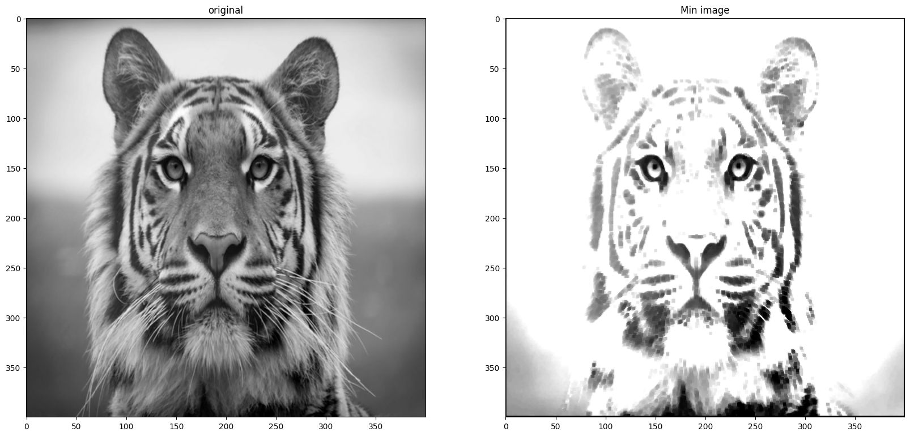

|  |  |  |  |  |
| --- | --- | --- | --- | --- |
| In [4]: | |  |  |  | | --- | --- | --- | | **def** max_filter(input_image):  img **=** input_image**.**resize((400,400), Image**.**Resampling**.**LANCZOS)  fig **=** plt**.**figure()  fig**.**set_figheight(20)  fig**.**set_figwidth(20)  *#plotting original image*  fig**.**add_subplot(1,2,1)  plt**.**imshow(img, cmap**=**'gray')   |  | | --- | | plt**.**title('original') |  |  | | --- | | *# convert to numpy array* |   numpy_image **=** np**.**array(img)   *# array for padding*  array_b **=** np**.**zeros((402,402))  *# to pad initial array with zeros in all side* array_b[1:401,1:401]**=** numpy_image  *#defining filter*  *#filter_array = np.array([[1,1,1],*   *# [1,1,1],*   *# [1,1,1]])*  filter_array **=** np**.**array([[3,3,3],  [3,3,3],  [3,3,3]]) | |

|  |
| --- |
| *#creating empty list*  lst **=**[]  **for** i **in** range(400):  **for** j **in** range(400):   *#extracting part of array equal to filter size* array_c **=** array_b[i:(3**+**i),j:(3**+**j)]  *#applying filter*  array_mul **=** np**.**multiply(filter_array,array_c) array_sum **=** np**.**max(array_mul)  *# putting calculated value in list*  lst**.**append(array_sum)  *# resizing lst to shape of original array* final_array **=** np**.**resize(lst,(400,400))  final_image **=** Image**.**fromarray(final_array) final_image**=** final_image**.**convert("L")  *#plotting filtered image*  fig**.**add_subplot(1,2,2)  plt**.**imshow(final_image, cmap**=**'gray')  plt**.**title('Max image') |

|  |  |  |
| --- | --- | --- |
| In [5]: | |  | | --- | | *# reading image and converting to gray scale*  img **=** Image**.**open('../images/tiger.jpg')**.**convert('L') *# Call max filter function*  max_filter(img) | |

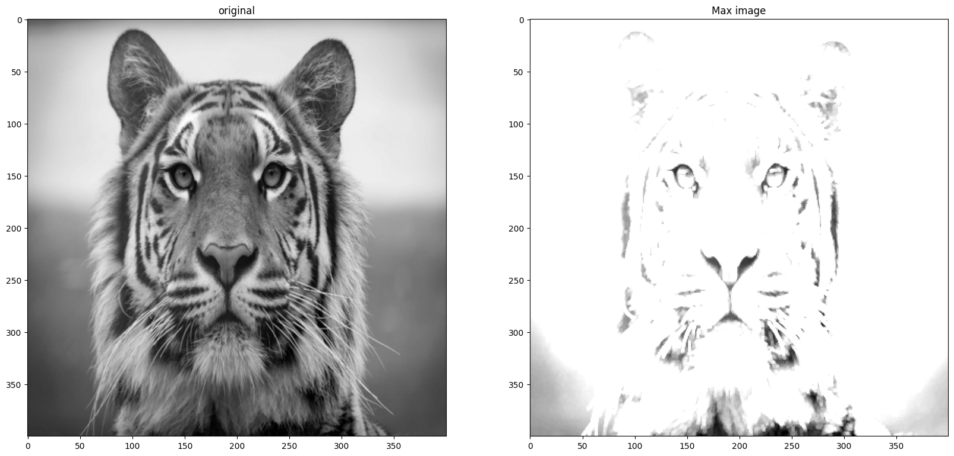

**Sharpening Filter**

|  |  |  |  |
| --- | --- | --- | --- |
| In [1]:  In [2]: | |  | | --- | | **import** numpy **as** np  **from** PIL **import** Image  **import** matplotlib.pyplot **as** plt |  |  | | --- | | **def** sharp_filter(input_image):  img **=** input_image**.**resize((400,400), Image**.**Resampling**.**LANCZOS)  fig **=** plt**.**figure()  fig**.**set_figheight(10)  fig**.**set_figwidth(10)  *#plotting original image*  fig**.**add_subplot(1,2,1)  plt**.**imshow(img, cmap**=**'gray')  plt**.**title('original')  *# convert to numpy array*   numpy_image **=** np**.**array(img)   *# array for padding*  array_b **=** np**.**zeros((402,402))  *# to pad initial array with zeros in all side* array_b[1:401,1:401]**=** numpy_image  *#defining filter*  filter_array **=** np**.**array([[**-**1**/**9,**-**1**/**9,**-**1**/**9], [**-**1**/**9,8**/**9,**-**1**/**9], [**-**1**/**9,**-**1**/**9,**-**1**/**9]])  *#creating empty list*  lst **=**[]  **for** i **in** range(400):  **for** j **in** range(400):   *#extracting part of array equal to filter size* array_c **=** array_b[i:(3**+**i),j:(3**+**j)]  *#applying filter*  array_mul **=** np**.**multiply(filter_array,array_c) array_sum **=** np**.**sum(array_mul)  *# putting calculated value in list*  lst**.**append(array_sum)  *# resizing lst to shape of original array* final_array **=** np**.**resize(lst,(400,400))  final_image **=** Image**.**fromarray(final_array) final_image**=** final_image**.**convert("L")  *#plotting filtered image*  fig**.**add_subplot(1,2,2) | |

|  |  |  |
| --- | --- | --- |
| |  | | --- | | plt**.**imshow(final_image, cmap**=**'gray') |  |  | | --- | | plt**.**title('filtered image') | |

|  |  |  |
| --- | --- | --- |
| In [3]: | |  | | --- | | *# reading image and converting to gray scale*  img **=** Image**.**open('../images/tiger.jpg')**.**convert('L') *# Sharpen the image*  sharp_filter(img) | |

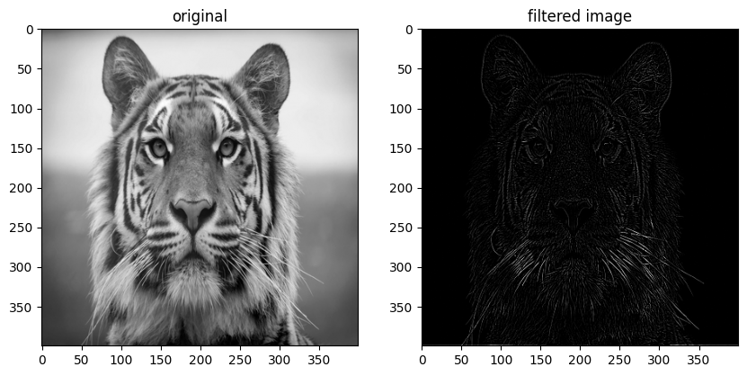

\***Smoothing Filter**\*

|  |  |  |  |
| --- | --- | --- | --- |
| In [1]:  In [2]: | |  | | --- | | **import** numpy **as** np  **from** PIL **import** Image  **import** matplotlib.pyplot **as** plt |  |  | | --- | | **def** smooth_filter(input_image):  img **=** input_image**.**resize((400,400), Image**.**Resampling**.**LANCZOS)  fig **=** plt**.**figure()  fig**.**set_figheight(20)  fig**.**set_figwidth(20)  *#plotting original image*  fig**.**add_subplot(1,2,1)  plt**.**imshow(img, cmap**=**'gray')  plt**.**title('original')  *# convert to numpy array*   numpy_image **=** np**.**array(img)   *# array for padding*  array_b **=** np**.**zeros((402,402))  *# to pad initial array with zeros in all side* array_b[1:401,1:401]**=** numpy_image  *#defining filter*  filter_array **=** np**.**array([[1**/**9,1**/**9,1**/**9],   [1**/**9,1**/**9,1**/**9],   [1**/**9,1**/**9,1**/**9]])  *#creating empty list*  lst **=**[]  **for** i **in** range(400):  **for** j **in** range(400):   *#extracting part of array equal to filter size* array_c **=** array_b[i:(3**+**i),j:(3**+**j)]  *#applying filter*  array_mul **=** np**.**multiply(filter_array,array_c) array_sum **=** np**.**sum(array_mul)  *# putting calculated value in list*  lst**.**append(array_sum)  *# resizing lst to shape of original array* final_array **=** np**.**resize(lst,(400,400))  final_image **=** Image**.**fromarray(final_array) final_image**=** final_image**.**convert("L")  *#plotting filtered image*  fig**.**add_subplot(1,2,2) | |

|  |  |  |
| --- | --- | --- |
| |  | | --- | | plt**.**imshow(final_image, cmap**=**'gray') |  |  | | --- | | plt**.**title('filtered image') | |

|  |  |  |
| --- | --- | --- |
| In [3]: | |  | | --- | | *# reading image and converting to gray scale*  img **=** Image**.**open('../images/tiger.jpg')**.**convert('L') *# Calling smooth function*  smooth_filter(img) | |

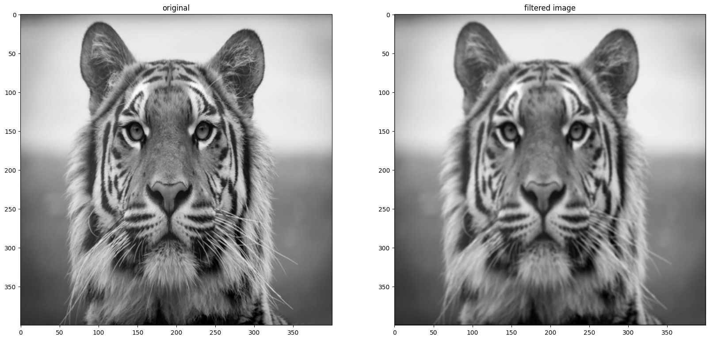

|  |  |  |
| --- | --- | --- |
| In [4]: | |  | | --- | | **def** weighted_smooth_filter(input_image):  img **=** input_image**.**resize((400,400), Image**.**Resampling**.**LANCZOS)  fig **=** plt**.**figure()  fig**.**set_figheight(20)  fig**.**set_figwidth(20)  *#plotting original image*  fig**.**add_subplot(1,2,1)  plt**.**imshow(img, cmap**=**'gray')  plt**.**title('original')  *# convert to numpy array*   numpy_image **=** np**.**array(img)   *# array for padding*  array_b **=** np**.**zeros((402,402))  *# to pad initial array with zeros in all side* array_b[1:401,1:401]**=** numpy_image  *#defining filter*  filter_array **=** np**.**array([[1**/**16,2**/**16,1**/**16], [2**/**16,4**/**16,2**/**16], [1**/**16,2**/**16,1**/**16]]) *#creating empty list*  lst **=**[]  **for** i **in** range(400):  **for** j **in** range(400):   *#extracting part of array equal to filter size* array_c **=** array_b[i:(3**+**i),j:(3**+**j)]  *#applying filter*  array_mul **=** np**.**multiply(filter_array,array_c) | |

|  |  |  |  |  |  |  |  |  |
| --- | --- | --- | --- | --- | --- | --- | --- | --- |
| |  | | --- | | array_sum **=** np**.**sum(array_mul) |  |  | | --- | | *# putting calculated value in list* |  |  | | --- | | lst**.**append(array_sum) |  |  | | --- | | *# resizing lst to shape of original array* |  |  | | --- | | final_array **=** np**.**resize(lst,(400,400)) |  |  | | --- | | final_image **=** Image**.**fromarray(final_array) |  |  | | --- | | final_image**=** final_image**.**convert("L") |  |  | | --- | | *#plotting filtered image* |   fig**.**add_subplot(1,2,2)  plt**.**imshow(final_image, cmap**=**'gray')  plt**.**title('filtered image') |

|  |  |  |
| --- | --- | --- |
| In [5]: | |  | | --- | | weighted_smooth_filter(img) | |

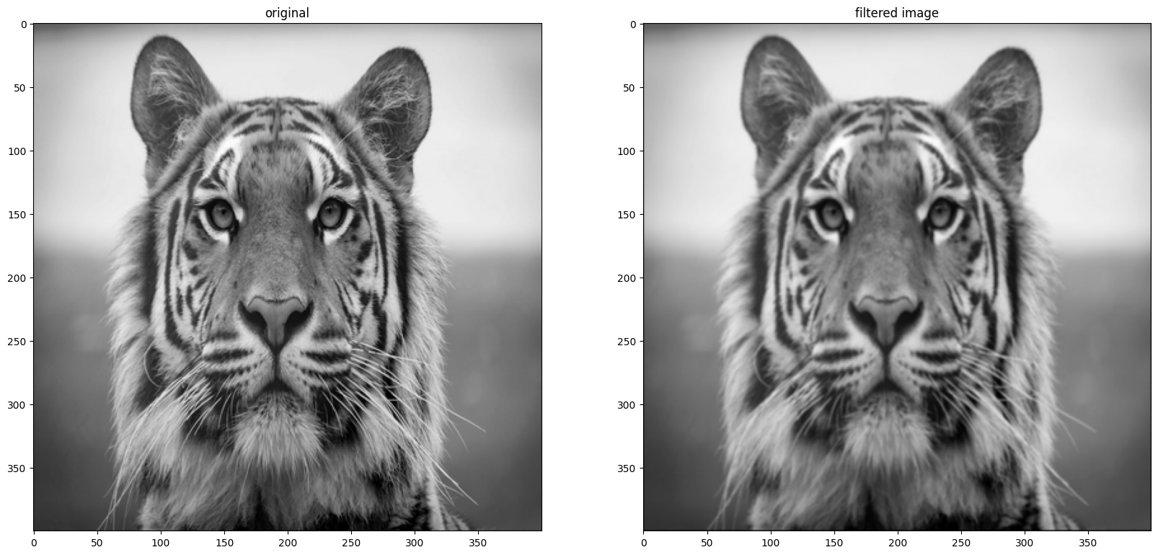

**1st Derivative Filter**   
\***Prewitt Operator**\*   
$$ \begin{bmatrix} -1 & -1 & -1\\ 0 & 0 & 0 \\ 1 & 1 & 1 \end{bmatrix} $$$$ \begin{bmatrix} -1 & 0 & 1\\ -1 & 0 & 1 \\ -1 & 0 & 1 \end{bmatrix} $$

|  |  |  |  |  |  |  |  |  |
| --- | --- | --- | --- | --- | --- | --- | --- | --- |
| In [1]:  In [2]:  In [3]: | |  | | --- | | **import** numpy **as** np  **from** PIL **import** Image  **import** matplotlib.pyplot **as** plt |  |  | | --- | | **def** Prewitt_Operator_horizontal(input_image):  img **=** input_image**.**resize((400,400), Image**.**Resampling**.**LANCZOS) *# convert to numpy array*   numpy_image **=** np**.**array(img)   *# array for padding*  array_b **=** np**.**zeros((402,402))   *# to pad initial array with zeros in all side*  array_b[1:401,1:401]**=** numpy_image   *#defining filter*  filter_array **=** np**.**array([[**-**1,**-**1,**-**1],   [0,0,0],   [1,1,1]])   *#creating empty list*  lst **=**[]   **for** i **in** range(400):   **for** j **in** range(400):   *#extracting part of array equal to filter size*  array_c **=** array_b[i:(3**+**i),j:(3**+**j)]   *#applying filter*  array_mul **=** np**.**multiply(filter_array,array_c)  array_sum **=** np**.**sum(array_mul)   *# putting calculated value in list*  lst**.**append(array_sum)   *# resizing lst to shape of original array*  final_array **=** np**.**resize(lst,(400,400))  final_image **=** Image**.**fromarray(final_array)  final_image**=** final_image**.**convert("L")   **return** final_image |  |  |  |  |  |  | | --- | --- | --- | --- | --- | | |  | | --- | | **def** Prewitt_Operator_vertical(input_image): |  |  | | --- | | img **=** input_image**.**resize((400,400), Image**.**Resampling**.**LANCZOS) |  |  | | --- | | *# convert to numpy array* |  |  | | --- | | numpy_image **=** np**.**array(img) | | |

|  |
| --- |
| *# array for padding*  array_b **=** np**.**zeros((402,402))   *# to pad initial array with zeros in all side* array_b[1:401,1:401]**=** numpy_image   *#defining filter*  filter_array **=** np**.**array([[**-**1,0,1],   [**-**1,0,1],   [**-**1,0,1]])   *#creating empty list*  lst **=**[]   **for** i **in** range(400):   **for** j **in** range(400):   *#extracting part of array equal to filter size* array_c **=** array_b[i:(3**+**i),j:(3**+**j)]   *#applying filter*  array_mul **=** np**.**multiply(filter_array,array_c) array_sum **=** np**.**sum(array_mul)   *# putting calculated value in list*  lst**.**append(array_sum)   *# resizing lst to shape of original array*  final_array **=** np**.**resize(lst,(400,400))  final_image **=** Image**.**fromarray(final_array)  final_image**=** final_image**.**convert("L")   **return** final_image |

\***Sobel Operator**\*

$$ \begin{bmatrix} -1 & -2 & -1\\ 0 & 2 & 0 \\ 1 & 2 & 1 \end{bmatrix} $$$$ \begin{bmatrix} -1 & 0 & 1\\ -2 & 0 & 2 \\ -1 & 0 & 1 \end{bmatrix} $$

|  |  |  |  |  |  |  |  |  |  |  |  |  |
| --- | --- | --- | --- | --- | --- | --- | --- | --- | --- | --- | --- | --- |
| In [4]: | |  |  |  |  |  |  |  |  |  |  |  | | --- | --- | --- | --- | --- | --- | --- | --- | --- | --- | --- | | **def** Sobel_Operator_horizontal(input_image):   |  | | --- | | img **=** input_image**.**resize((400,400), Image**.**Resampling**.**LANCZOS) |  |  | | --- | | *# convert to numpy array* |   numpy_image **=** np**.**array(img)   *# array for padding*   |  | | --- | | array_b **=** np**.**zeros((402,402)) |  |  | | --- | | *# to pad initial array with zeros in all side* |  |  | | --- | | array_b[1:401,1:401]**=** numpy_image |  |  | | --- | | *#defining filter* |   filter_array **=** np**.**array([[**-**1,**-**2,**-**1],   [0,0,0],   |  | | --- | | [1,2,1]]) |  |  | | --- | | *#creating empty list* |  |  | | --- | | lst **=**[] |  |  | | --- | | **for** i **in** range(400): | | |

|  |  |  |  |  |  |  |  |  |  |  |
| --- | --- | --- | --- | --- | --- | --- | --- | --- | --- | --- |
| **for** j **in** range(400):   *#extracting part of array equal to filter size*   |  | | --- | | array_c **=** array_b[i:(3**+**i),j:(3**+**j)] |  |  | | --- | | *#applying filter* |   array_mul **=** np**.**multiply(filter_array,array_c)   |  | | --- | | array_sum **=** np**.**sum(array_mul) |  |  | | --- | | *# putting calculated value in list* |  |  | | --- | | lst**.**append(array_sum) |  |  | | --- | | *# resizing lst to shape of original array* |  |  | | --- | | final_array **=** np**.**resize(lst,(400,400)) |  |  | | --- | | final_image **=** Image**.**fromarray(final_array) |  |  | | --- | | final_image**=** final_image**.**convert("L") |  |  | | --- | | **return** final_image | |

|  |  |  |
| --- | --- | --- |
| In [5]: | |  | | --- | | **def** Sobel_Operator_vertical(input_image):  img **=** input_image**.**resize((400,400), Image**.**Resampling**.**LANCZOS) *# convert to numpy array*   numpy_image **=** np**.**array(img)   *# array for padding*  array_b **=** np**.**zeros((402,402))   *# to pad initial array with zeros in all side*  array_b[1:401,1:401]**=** numpy_image   *#defining filter*  filter_array **=** np**.**array([[**-**1,0,1],   [**-**2,0,2],   [**-**1,0,1]])   *#creating empty list*  lst **=**[]   **for** i **in** range(400):   **for** j **in** range(400):   *#extracting part of array equal to filter size*  array_c **=** array_b[i:(3**+**i),j:(3**+**j)]   *#applying filter*  array_mul **=** np**.**multiply(filter_array,array_c)  array_sum **=** np**.**sum(array_mul)   *# putting calculated value in list*  lst**.**append(array_sum)   *# resizing lst to shape of original array*  final_array **=** np**.**resize(lst,(400,400))  final_image **=** Image**.**fromarray(final_array)  final_image**=** final_image**.**convert("L")   **return** final_image | |

|  |  |  |  |
| --- | --- | --- | --- |
| In [6]:  In [7]:  Out[7]: | |  | | --- | | *# reading image and converting to gray scale*  img **=** Image**.**open('../images/tiger.jpg')**.**convert('L')**.**resize((400,400)) *# img = input_image.resize((400,400), Image.Resampling.LANCZOS) # Calling function*  Prewitt_Operator_horizontal_image **=** Prewitt_Operator_horizontal(img) Prewitt_Operator_vertical_image **=** Prewitt_Operator_vertical(img) Sobel_Operator_horizontal_image **=** Sobel_Operator_horizontal(img) Sobel_Operator_vertical_image **=** Sobel_Operator_vertical(img) |  |  | | --- | | fig **=** plt**.**figure()  fig**.**set_figheight(10)  fig**.**set_figwidth(16)  *#plotting original image*  fig**.**add_subplot(2,3,1)  plt**.**imshow(img, cmap**=**'gray')  plt**.**title('original')  *#plotting filtered image*  fig**.**add_subplot(2,3,2)  plt**.**imshow(Prewitt_Operator_horizontal_image, cmap**=**'gray') plt**.**title('Prewitt_Operator_horizontal')  *#plotting filtered image*  fig**.**add_subplot(2,3,3)  plt**.**imshow(Prewitt_Operator_vertical_image, cmap**=**'gray') plt**.**title('Prewitt_Operator_Vertical')  *#plotting filtered image*  fig**.**add_subplot(2,3,4)  plt**.**imshow(Sobel_Operator_horizontal_image, cmap**=**'gray') plt**.**title('Sobel_Operator_horizontal')  *#plotting filtered image*  fig**.**add_subplot(2,3,5)  plt**.**imshow(Sobel_Operator_vertical_image, cmap**=**'gray') plt**.**title('Sobel_Operator_vertical') |   Text(0.5, 1.0, 'Sobel_Operator_vertical') |

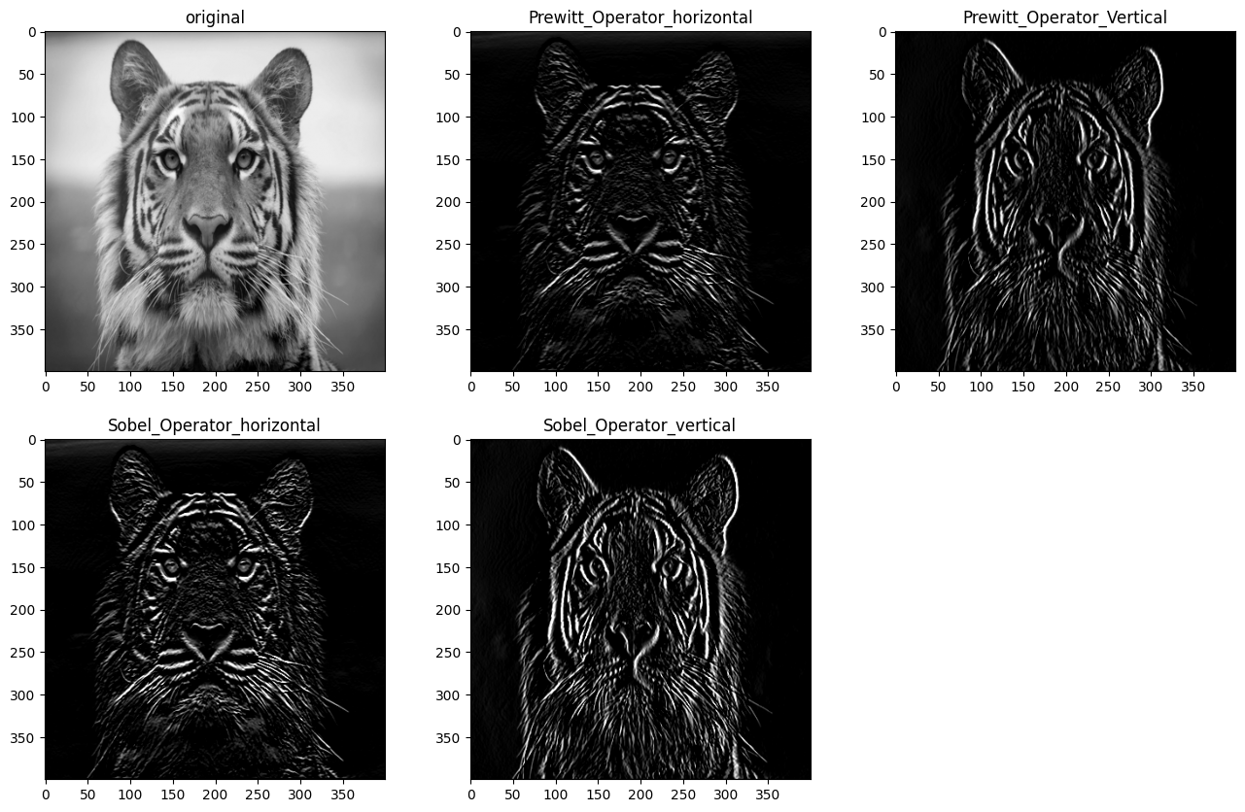

\***Laplacian Filter**\*   
$$ \begin{bmatrix} 0 & 1 & 0\\ 1 & -4 & 1 \\ 0 & 1 & 0 \end{bmatrix} $$   
Applying Laplacian filter to an image get a new image that highlights edges and other discontinuties

|  |  |  |  |
| --- | --- | --- | --- |
| In [1]:  In [2]: | |  | | --- | | **import** numpy **as** np  **from** PIL **import** Image  **import** matplotlib.pyplot **as** plt |  |  | | --- | | **def** Laplacian_filter(input_image):  img **=** input_image**.**resize((400,400), Image**.**Resampling**.**LANCZOS)  fig **=** plt**.**figure()  fig**.**set_figheight(20)  fig**.**set_figwidth(20)  *#plotting original image*  fig**.**add_subplot(1,2,1)  plt**.**imshow(img, cmap**=**'gray')  plt**.**title('original')  *# convert to numpy array*   numpy_image **=** np**.**array(img)   *# array for padding*  array_b **=** np**.**zeros((402,402))  *# to pad initial array with zeros in all side* array_b[1:401,1:401]**=** numpy_image  *#defining filter*  filter_array **=** np**.**array([[0,1,0],   [1,**-**4,1],   [0,1,0]])  *#creating empty list*  lst **=**[]  **for** i **in** range(400):  **for** j **in** range(400):   *#extracting part of array equal to filter size* array_c **=** array_b[i:(3**+**i),j:(3**+**j)]  *#applying filter*  array_mul **=** np**.**multiply(filter_array,array_c) array_sum **=** np**.**sum(array_mul)  *# putting calculated value in list*  lst**.**append(array_sum)  *# resizing lst to shape of original array* final_array **=** np**.**resize(lst,(400,400))  final_image **=** Image**.**fromarray(final_array) | |

|  |  |  |  |  |  |
| --- | --- | --- | --- | --- | --- |
| |  | | --- | | final_image**=** final_image**.**convert("L") |  |  | | --- | | *#plotting filtered image* |  |  | | --- | | fig**.**add_subplot(1,2,2) |  |  | | --- | | plt**.**imshow(final_image, cmap**=**'gray') |  |  | | --- | | plt**.**title('Laplacian filtered image') | |

|  |  |  |
| --- | --- | --- |
| In [3]: | |  | | --- | | *# reading image and converting to gray scale*  img **=** Image**.**open('../images/tiger.jpg')**.**convert('L') *# Calling function*  Laplacian_filter(img) | |

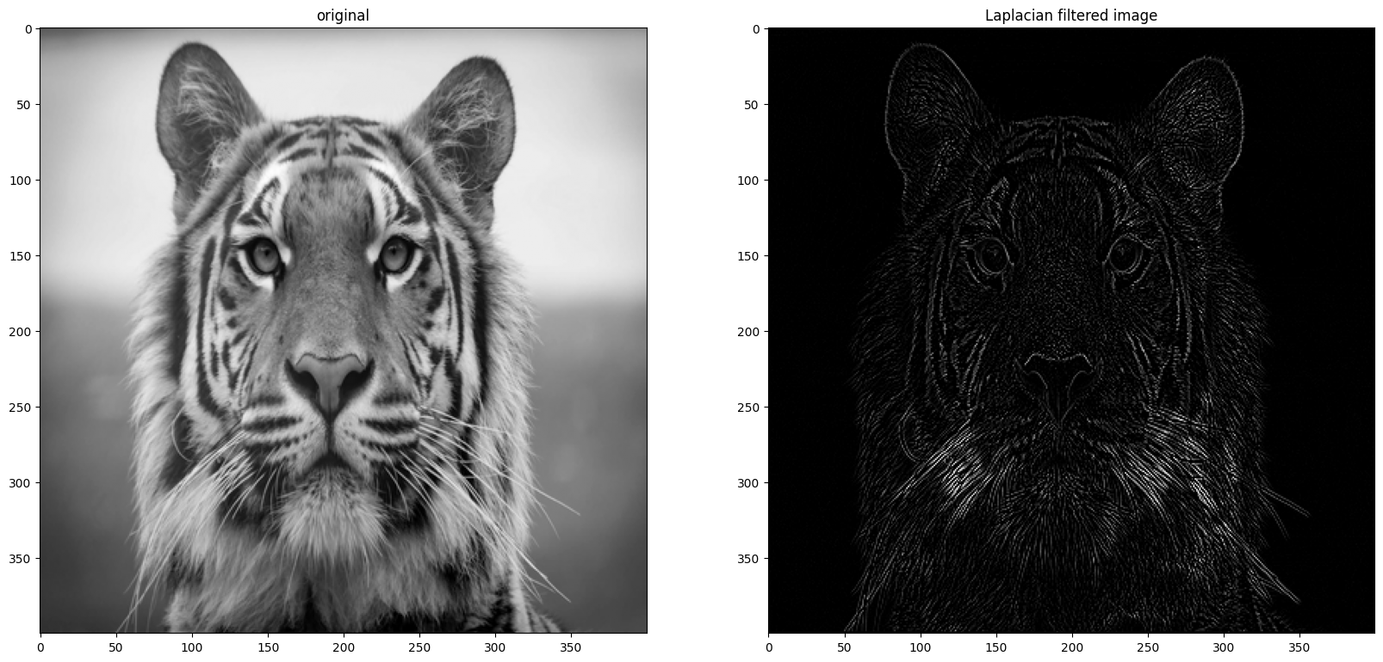

\***Variants of Laplace**\*

subtract laplace from original image to generate our final sharpened enhanced image

$$ \begin{bmatrix} 0 & -1 & 0\\ -1 & 5 & -1 \\ 0 & -1 & 0 \end{bmatrix} $$

|  |  |  |
| --- | --- | --- |
| In [4]: | |  | | --- | | **def** Sharpened_Laplacian_filter(input_image):  img **=** input_image**.**resize((400,400), Image**.**Resampling**.**LANCZOS)  fig **=** plt**.**figure()  fig**.**set_figheight(20)  fig**.**set_figwidth(20)  *#plotting original image*  fig**.**add_subplot(1,2,1)  plt**.**imshow(img, cmap**=**'gray')  plt**.**title('original')  *# convert to numpy array*   numpy_image **=** np**.**array(img)   *# array for padding*  array_b **=** np**.**zeros((402,402))  *# to pad initial array with zeros in all side* array_b[1:401,1:401]**=** numpy_image  *#defining filter*  filter_array **=** np**.**array([[0,**-**1,0],   [**-**1,5,**-**1],   [0,**-**1,0]]) | |

|  |
| --- |
| *#creating empty list*  lst **=**[]  **for** i **in** range(400):  **for** j **in** range(400):   *#extracting part of array equal to filter size* array_c **=** array_b[i:(3**+**i),j:(3**+**j)]  *#applying filter*  array_mul **=** np**.**multiply(filter_array,array_c) array_sum **=** np**.**sum(array_mul)  *# putting calculated value in list*  lst**.**append(array_sum)  *# resizing lst to shape of original array* final_array **=** np**.**resize(lst,(400,400))  final_image **=** Image**.**fromarray(final_array) final_image**=** final_image**.**convert("L")  *#plotting filtered image*  fig**.**add_subplot(1,2,2)  plt**.**imshow(final_image, cmap**=**'gray')  plt**.**title('filtered image') |

|  |  |  |
| --- | --- | --- |
| In [5]: | |  | | --- | | *# reading image and converting to gray scale*  img **=** Image**.**open('../images/tiger.jpg')**.**convert('L') *# Calling function*  Sharpened_Laplacian_filter(img) | |

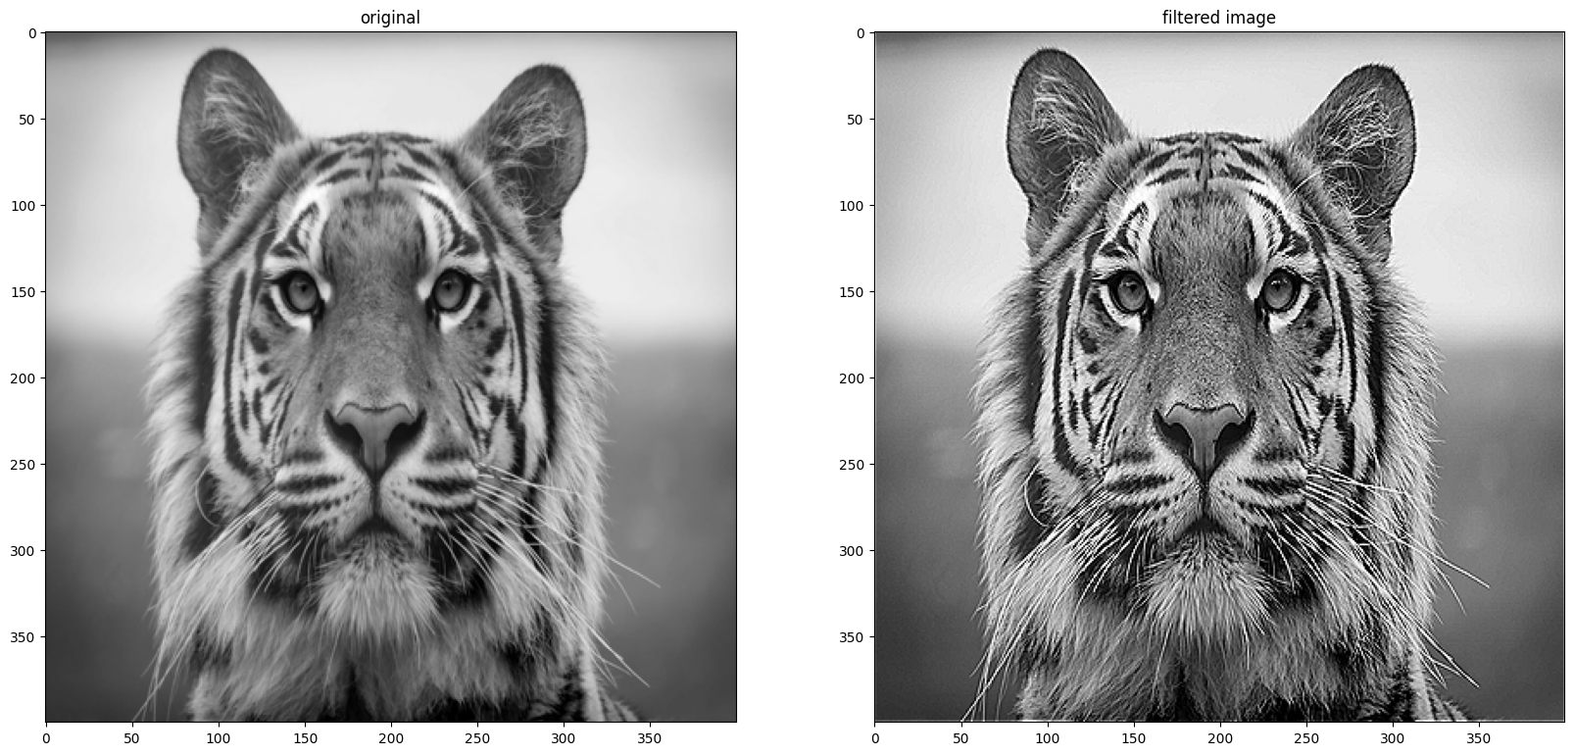

Variant 1

$$ \begin{bmatrix} 1 & 1 & 1\\ 1 & -8 & 1 \\ 1 & 1 & 1 \end{bmatrix} $$

|  |  |  |  |  |  |  |  |
| --- | --- | --- | --- | --- | --- | --- | --- |
| In [6]: | |  |  |  |  |  |  | | --- | --- | --- | --- | --- | --- | | |  | | --- | | **def** Laplacian_Variant1(input_image): |  |  | | --- | | img **=** input_image**.**resize((400,400), Image**.**Resampling**.**LANCZOS) |  |  | | --- | | fig **=** plt**.**figure() |  |  | | --- | | fig**.**set_figheight(20) |  |  | | --- | | fig**.**set_figwidth(20) | | |

|  |
| --- |
| *#plotting original image*  fig**.**add_subplot(1,2,1)  plt**.**imshow(img, cmap**=**'gray')  plt**.**title('original')  *# convert to numpy array*   numpy_image **=** np**.**array(img)   *# array for padding*  array_b **=** np**.**zeros((402,402))  *# to pad initial array with zeros in all side* array_b[1:401,1:401]**=** numpy_image  *#defining filter*  filter_array **=** np**.**array([[1,1,1],   [1,**-**8,1],   [1,1,1]])  *#creating empty list*  lst **=**[]  **for** i **in** range(400):  **for** j **in** range(400):   *#extracting part of array equal to filter size* array_c **=** array_b[i:(3**+**i),j:(3**+**j)]  *#applying filter*  array_mul **=** np**.**multiply(filter_array,array_c) array_sum **=** np**.**sum(array_mul)  *# putting calculated value in list*  lst**.**append(array_sum)  *# resizing lst to shape of original array* final_array **=** np**.**resize(lst,(400,400))  final_image **=** Image**.**fromarray(final_array) final_image**=** final_image**.**convert("L")  *#plotting filtered image*  fig**.**add_subplot(1,2,2)  plt**.**imshow(final_image, cmap**=**'gray')  plt**.**title('Laplace variant1 filtered image') |

|  |  |  |
| --- | --- | --- |
| In [7]: | |  | | --- | | Laplacian_Variant1(img) | |

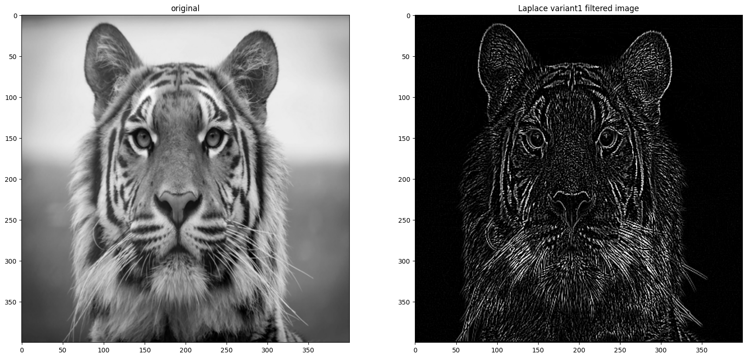

Variant 2   
$$ \begin{bmatrix} -1 & -1 & -1\\ -1 & 9 & -1 \\ -1 & -1 & -1 \end{bmatrix} $$

|  |  |  |
| --- | --- | --- |
| In [8]: | |  | | --- | | **def** Laplacian_Variant2(input_image):  img **=** input_image**.**resize((400,400), Image**.**Resampling**.**LANCZOS)  fig **=** plt**.**figure()  fig**.**set_figheight(20)  fig**.**set_figwidth(20)  *#plotting original image*  fig**.**add_subplot(1,2,1)  plt**.**imshow(img, cmap**=**'gray')  plt**.**title('original')  *# convert to numpy array*   numpy_image **=** np**.**array(img)   *# array for padding*  array_b **=** np**.**zeros((402,402))  *# to pad initial array with zeros in all side* array_b[1:401,1:401]**=** numpy_image  *#defining filter*  filter_array **=** np**.**array([[**-**1,**-**1,**-**1],   [**-**1,9,**-**1],   [**-**1,**-**1,**-**1]])  *#creating empty list*  lst **=**[]  **for** i **in** range(400):  **for** j **in** range(400):   *#extracting part of array equal to filter size* array_c **=** array_b[i:(3**+**i),j:(3**+**j)]  *#applying filter*  array_mul **=** np**.**multiply(filter_array,array_c) array_sum **=** np**.**sum(array_mul)  *# putting calculated value in list*  lst**.**append(array_sum) | |

|  |  |  |  |  |  |  |  |  |
| --- | --- | --- | --- | --- | --- | --- | --- | --- |
| |  | | --- | | *# resizing lst to shape of original array* |  |  | | --- | | final_array **=** np**.**resize(lst,(400,400)) |  |  | | --- | | final_image **=** Image**.**fromarray(final_array) |  |  | | --- | | final_image**=** final_image**.**convert("L") |  |  | | --- | | *#plotting filtered image* |  |  | | --- | | fig**.**add_subplot(1,2,2) |  |  | | --- | | plt**.**imshow(final_image, cmap**=**'gray') |  |  | | --- | | plt**.**title('Laplace variant2 filtered image') | |

|  |  |  |
| --- | --- | --- |
| In [9]: | |  | | --- | | Laplacian_Variant2(img) | |

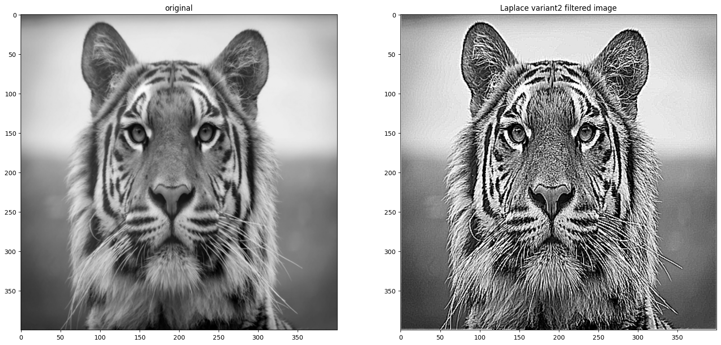

\***Frequency Domain Filtering**\*   
Steps in frequency domain filtering

|  |  |  |
| --- | --- | --- |
| In [1]: |  | Compute the Fourier Transform |
|  | Multiply the result by a filter transform function |
|  | Take the inverse transform to produce the enchanced image |
| |  | | --- | | **from** scipy **import** fftpack  **import** numpy **as** np  **import** imageio.v2 **as** imageio  **from** PIL **import** Image, ImageDraw  **import** matplotlib.pyplot **as** plt | | |
| In [2]: | |  |  | | --- | --- | | |  | | --- | | **def** frequency_image(image):  image_array **=** np**.**array(image)  fft1 **=** fftpack**.**fftshift(fftpack**.**fft2(image_array)) magnitude_spectrum **=**20**\***np**.**log(np**.**abs(fft1))  freq_image **=** Image**.**fromarray(magnitude_spectrum) freq_image **=** freq_image**.**convert("L")   **return** freq_image | | | |
| In [3]: | |  | | --- | | **def** low_pass_filter(image1):   *#convert image to numpy array*  image1_np**=**np**.**array(image1)   *#fft of image*  fft1 **=** fftpack**.**fftshift(fftpack**.**fft2(image1_np)) *#Create a low pass filter image*  x,y **=** image1_np**.**shape[0],image1_np**.**shape[1]  *#defining filter*   *#size of circle*  e_x,e_y**=**50,50   *#create a box*   bbox**=**((x**/**2)**-**(e_x**/**2),(y**/**2)**-**(e_y**/**2),(x**/**2)**+**(e_x**/**2),(y**/**2)**+**(e_y**/**2))  low_pass**=**Image**.**new("L",(image1_np**.**shape[0],image1_np**.**shape[1]),color**=**0) draw1**=**ImageDraw**.**Draw(low_pass)  draw1**.**ellipse(bbox, fill**=**1)  low_pass_np**=**np**.**array(low_pass)  low_pass_np **=** low_pass_np**.**T   *#end of defining filter*  *#multiply both the images*  filtered**=**np**.**multiply(fft1,low_pass_np)  *#inverse fft*  ifft2 **=** np**.**real(fftpack**.**ifft2(fftpack**.**ifftshift(filtered))) ifft2 **=** np**.**maximum(0, np**.**minimum(ifft2,255))  data **=** Image**.**fromarray(ifft2)  data **=** data**.**convert("L")  **return** data | | |

|  |  |  |  |
| --- | --- | --- | --- |
| In [4]:  In [5]:  Out[5]: | |  | | --- | | **def** high_pass_filter(image):  *#converting image to array*  image_array **=** np**.**array(image)  *#sending image to low pass filter*  lowpass_image **=** low_pass_filter(image)   *#converting image to array*  lowpass_image_array **=** np**.**array(lowpass_image)  *#subtracting lowpass image from original to obtain highpass image* high_pass_array **=** image_array **-** lowpass_image_array  *#array to image*  high_pass_image **=** Image**.**fromarray(high_pass_array) high_pass_image **=** high_pass_image**.**convert("L")  **return** high_pass_image |  |  | | --- | | image **=** imageio**.**imread('../images/tiger.jpg', mode**=**'L') freq_image **=** frequency_image(image)  lowpass_image **=** low_pass_filter(image)  highpass_image **=** high_pass_filter(image)  fig **=** plt**.**figure()  fig**.**set_figheight(12)  fig**.**set_figwidth(10)  *#plotting original image*  fig**.**add_subplot(2,2,1)  plt**.**imshow(image, cmap**=**'gray')  plt**.**title('original')  *#plotting the image in frequency domain*  fig**.**add_subplot(2,2,2)  plt**.**imshow(freq_image, cmap**=**'gray')  plt**.**title('Frequency Domain')  *#plotting lowpass image*  fig**.**add_subplot(2,2,3)  plt**.**imshow(lowpass_image, cmap**=**'gray')  plt**.**title('lowpass_image')  *#plotting highpass image*  fig**.**add_subplot(2,2,4)  plt**.**imshow(highpass_image, cmap**=**'gray')  plt**.**title('highpass_image') |   Text(0.5, 1.0, 'highpass_image') |

